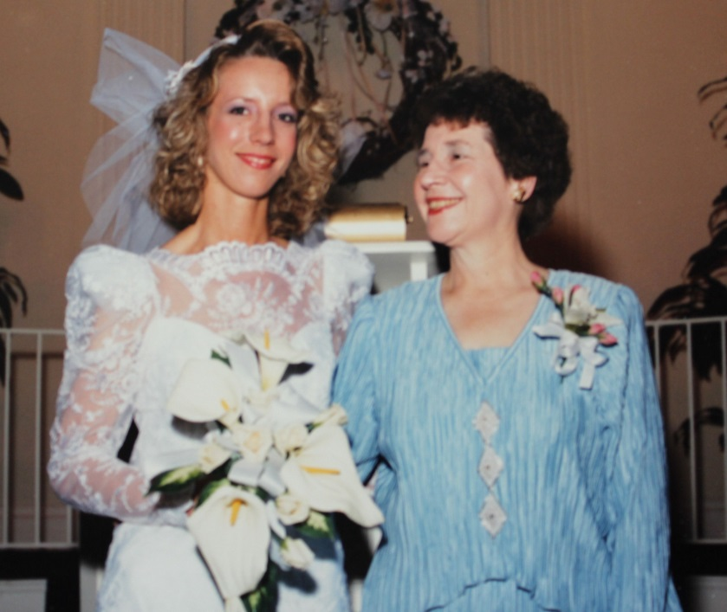

(l-r) Judie Ann and her mother, Jo Ann Marilyn Clark List - 1989

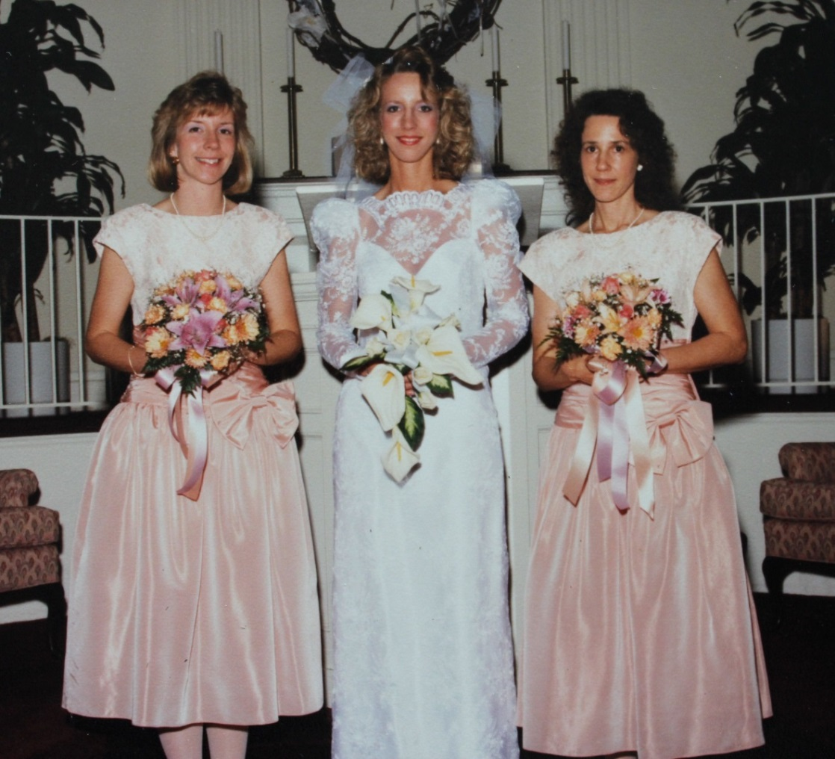

(l-r) Marilyn, Judie, and Susan List - 1989